# **IOT Project Report**

**Abstract**:

Refrigerators play a crucial role in modern households by preserving perishable items and extending their shelf life. However, conventional refrigerators often lack advanced control systems to effectively manage internal conditions. To address this limitation, this project focuses on developing an intelligent control system for refrigerators using Arduino microcontroller technology. The system integrates a variety of sensors and actuators to create a responsive environment within the refrigerator, enhancing user convenience and ensuring optimal storage conditions for food items.

The primary objective of this project is to design a control system capable of monitoring temperature fluctuations, detecting human presence, and assessing the quantity of items inside the fridge. By leveraging Arduino's versatility, the system can dynamically adjust settings based on sensor inputs to maintain ideal temperature levels and provide timely feedback to users.

Key components of the system include temperature sensors for monitoring internal temperature, PIR motion sensors to detect human presence and initiate appropriate actions, force sensors to determine the quantity of items inside the fridge, LEDs for visual feedback, an LCD display for presenting real-time information, and a fan for temperature regulation.

The development process involves the integration of these components into a cohesive system architecture, followed by the implementation of control logic using Arduino programming. The system utilizes a continuous feedback loop to collect sensor data, analyse it, and execute control actions accordingly.

Through rigorous testing and optimization, the implemented control system demonstrates robust performance and reliability. It effectively maintains optimal temperature conditions, minimizes energy consumption, and enhances the overall user experience.

**Introduction :**

Refrigerators have become indispensable appliances in modern households, serving as essential tools for preserving perishable food items and maintaining their freshness for extended periods. The evolution of refrigerator technology has led to the introduction of various features aimed at improving energy efficiency, storage capacity, and overall convenience for users. However, traditional refrigerators often lack advanced control mechanisms to effectively manage internal conditions and adapt to changing environmental factors.

The introduction of smart technologies, such as Arduino microcontrollers, presents an opportunity to address these limitations and revolutionize the way refrigerators operate. By leveraging the flexibility and programmability of Arduino-based control systems, it becomes possible to create intelligent environments within refrigerators that can monitor, analyse, and respond to a wide range of parameters in real-time.

This project aims to explore the potential of Arduino microcontroller technology in designing and implementing an intelligent control system for refrigerators. The focus is on developing a system that can dynamically adjust settings based on sensor inputs to optimize temperature levels, detect human presence, and provide valuable feedback to users regarding the status of stored items.

The primary objective of this project is to enhance user convenience and food preservation capabilities by creating a responsive and adaptable refrigerator control system. By integrating various sensors, actuators, and control logic, the system aims to provide a seamless and intuitive user experience while ensuring optimal storage conditions for perishable items.

Through this project, we seek to demonstrate the feasibility and effectiveness of utilizing Arduino microcontrollers in revolutionizing traditional household appliances. By developing a robust and intelligent control system for refrigerators, we aim to contribute to the advancement of smart home technology and improve the quality of life for users worldwide.

**Project Description:**

The project involves the development of a sophisticated control system for refrigerators using Arduino microcontroller technology. The primary objective is to create an intelligent environment within the refrigerator, capable of autonomously monitoring and managing its internal conditions to ensure optimal food storage and preservation.

Key Functionalities:

1. Temperature Monitoring:

One of the core functionalities of the system is temperature monitoring. This is achieved using temperature sensors integrated into the refrigerator's interior. The sensors continuously measure the temperature and provide feedback to the control system.

2. Motion Detection:

The system incorporates Passive Infrared (PIR) motion sensors to detect human presence inside the refrigerator. This functionality serves multiple purposes, including activating internal lighting only when needed to conserve energy and alerting users to potential unauthorized access.

3. Item Quantity Assessment:

Force sensors are strategically placed within the refrigerator to detect pressure changes caused by the presence or absence of items. By analysing these pressure variations, the system can accurately determine the number of items inside the refrigerator. This information is valuable for inventory management and ensuring that the refrigerator is not overloaded, which could affect its cooling efficiency.

4. Real-time Feedback:

Visual feedback is provided to users through LED indicators strategically positioned on the refrigerator's exterior. These LEDs change colour based on the temperature conditions inside the refrigerator, allowing users to quickly assess whether the temperature is within the desired range without needing to open the appliance.

5. LCD Display:

Additionally, an LCD display is integrated into the system to provide more detailed information to users. The display shows the current temperature, the number of items detected inside the refrigerator, and any alerts or notifications regarding temperature fluctuations or other issues.

Operational Principle:

The system operates on a continuous feedback loop, where sensor readings are continuously monitored and analysed by the Arduino microcontroller. Based on predefined thresholds and control logic, the system makes decisions regarding temperature regulation, lighting activation, and feedback provision. For example, if the temperature exceeds a certain threshold, the system may activate a cooling mechanism such as a fan to regulate the temperature back to the desired range. Similarly, if motion is detected, the internal lighting may be activated temporarily to illuminate the refrigerator's contents.

**Methodology**:

The methodology employed in this project is designed to ensure a systematic and thorough approach to the development and implementation of the refrigerator control system. It consists of several distinct yet interconnected steps, each contributing to the overall success and effectiveness of the project.

1. Requirement Analysis:

In the initial phase, a detailed analysis of the project requirements is conducted. This involves engaging stakeholders to understand their needs and expectations regarding the functionality and performance of the refrigerator control system. Factors such as temperature range, motion detection sensitivity, and user interface preferences are carefully considered during this stage to ensure that the final product aligns with user expectations.

1. Component Selection and Integration:

Building upon the identified requirements, the appropriate electronic components and sensors are selected for integration into the system. This process involves evaluating various options based on factors such as accuracy, reliability, cost-effectiveness, and compatibility with the Arduino platform. Once selected, the components are seamlessly integrated into the system design, ensuring smooth interoperability and efficient utilization of resources.

1. Algorithm Development:

With the hardware components in place, the focus shifts to developing algorithms that govern the behaviour of the refrigerator control system. These algorithms are meticulously crafted to address specific tasks such as sensor data processing, decision-making logic, and feedback generation. Careful attention is paid to optimizing algorithm efficiency while maintaining robustness and accuracy in real-world scenarios.

1. Arduino Programming:

The heart of the system lies in the programming of the Arduino microcontroller, which serves as the central processing unit orchestrating the operation of the entire system. Using the Arduino Integrated Development Environment (IDE) and relevant libraries, the system's control logic is translated into Arduino code. This code is iteratively refined through rigorous testing and debugging to ensure its correctness and reliability.

1. Simulation and Testing:

Before deploying the system in a real-world environment, extensive simulation and testing are conducted to validate its functionality and performance. Simulation tools such as Tinker cad provide a virtual platform for assessing system behaviour under different conditions and scenarios. Additionally, real-world testing enables the verification of sensor accuracy, control responsiveness, and overall system stability.

1. Refinement and Optimization:

Throughout the development process, continuous refinement and optimization are key priorities. This involves fine-tuning parameters, optimizing algorithms for efficiency, and addressing any identified issues or shortcomings. User feedback and testing results are carefully considered to drive iterative improvements, ensuring that the final system meets or exceeds expectations in terms of functionality and usability.

Software:

**Arduino IDE (Integrated Development Environment):** Used for programming the microcontroller to interact with sensors and actuators

**Schematic Diagram:**

Schematic view of project from thinker cad.

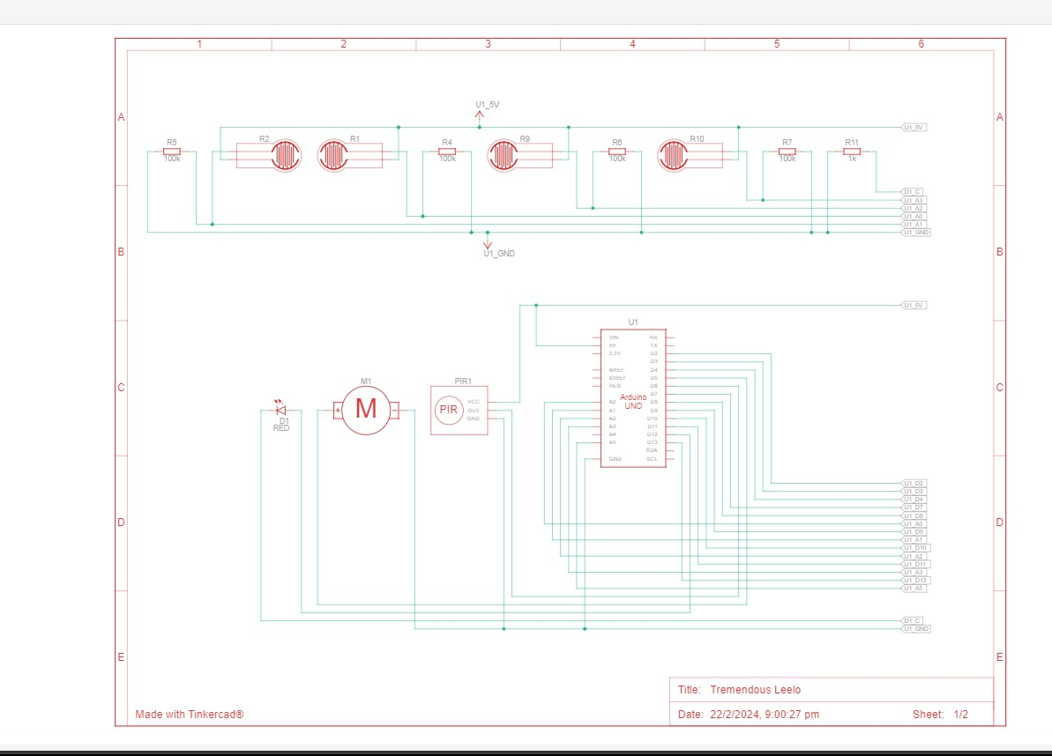

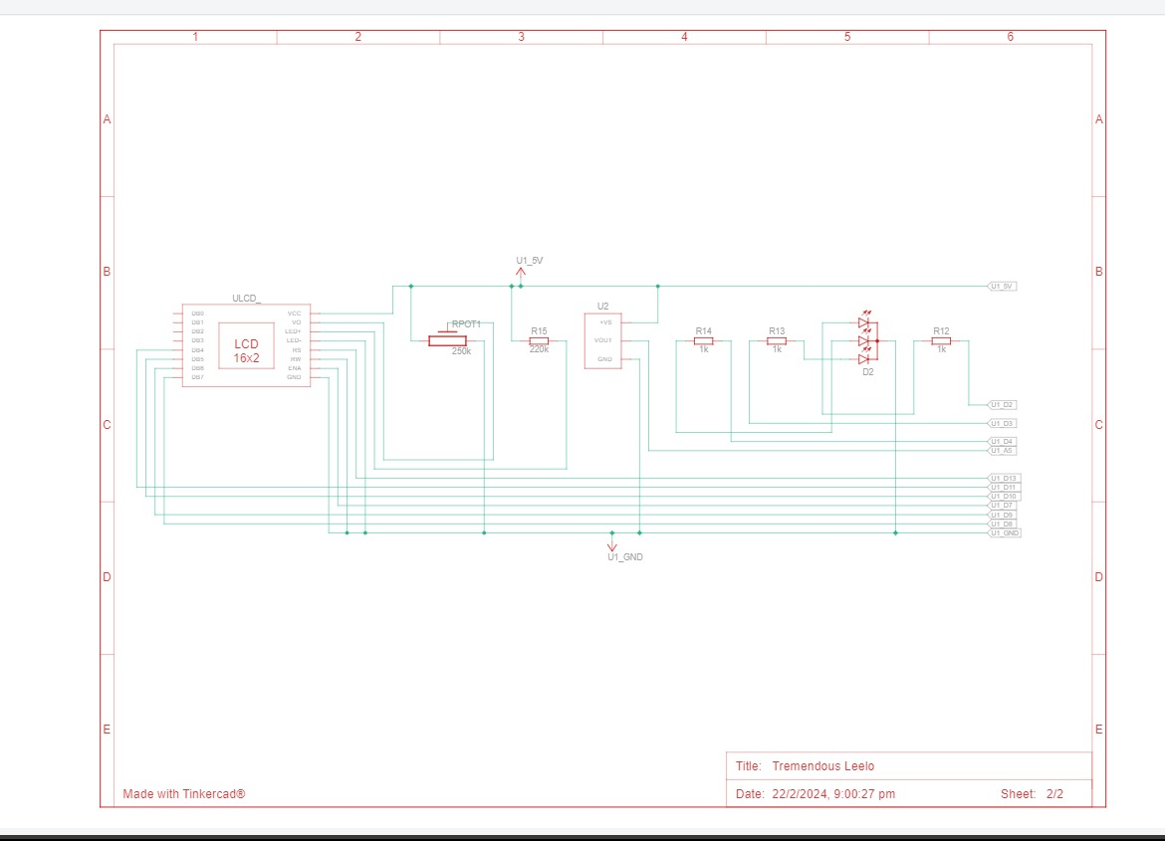

**Tinker cad:**

Implementation on software

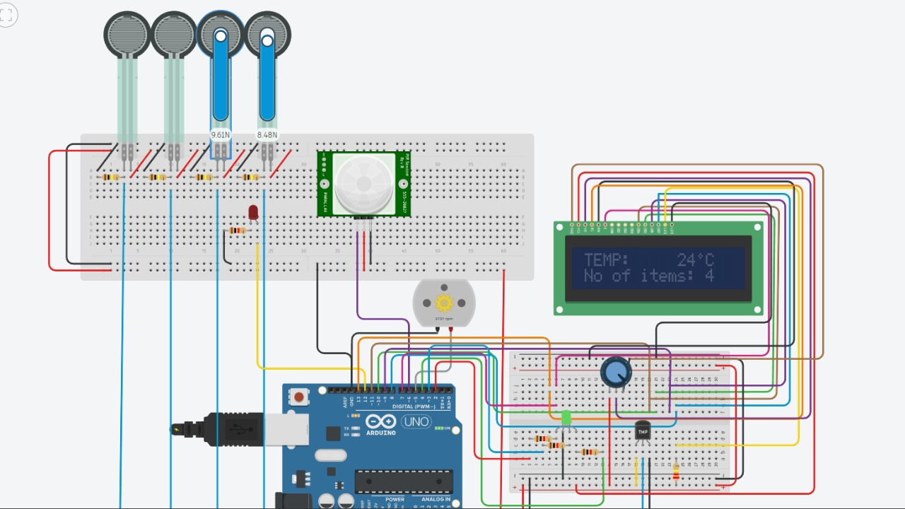

**Components**:

List of components that are used in the project

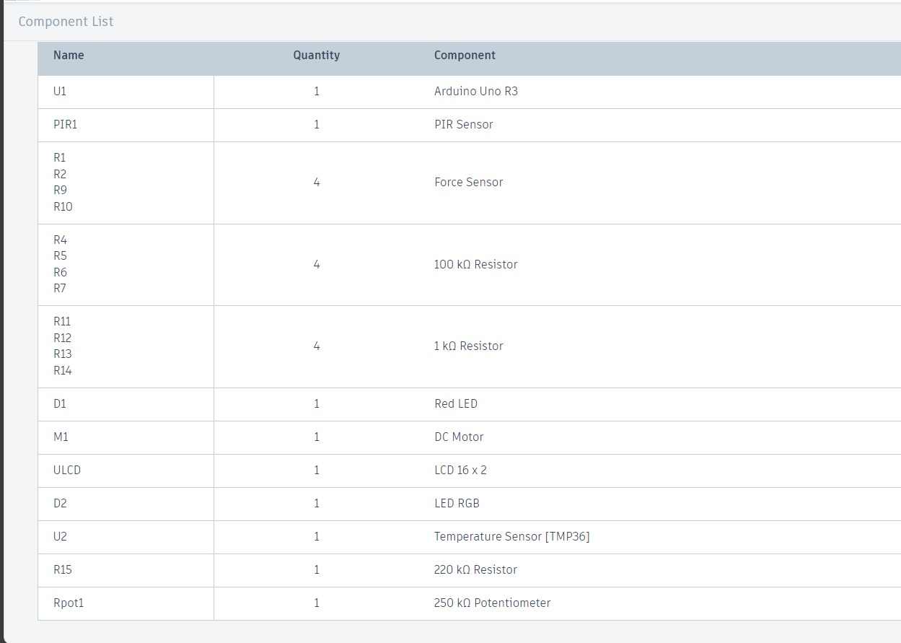

1. Arduino Microcontroller Board:

At the heart of the system lies the Arduino microcontroller board, serving as the central processing unit. It orchestrates the operation of the entire control system by processing sensor data, executing control algorithms, and interfacing with external components. The Arduino platform provides a versatile and user-friendly environment for developing embedded systems applications.

1. Temperature Sensor (e.g., LM35):

The temperature sensor is a crucial component responsible for monitoring the ambient temperature inside the refrigerator. One commonly used temperature sensor is the LM35, known for its high accuracy and linear output proportional to temperature. This sensor continuously provides real-time temperature readings to the Arduino microcontroller, enabling precise temperature control and monitoring.

1. Passive Infrared (PIR) Motion Sensor:

PIR motion sensors play a pivotal role in detecting human presence or motion within the refrigerator. These sensors utilize infrared radiation emitted by objects to detect changes in their surroundings. In the control system, PIR motion sensors trigger actions such as activating internal lighting when motion is detected, enhancing user convenience and energy efficiency.

1. Force Sensors:

Force sensors are strategically placed within the refrigerator to detect pressure variations caused by the presence or absence of items. These sensors employ various technologies such as strain gauges or piezoelectric elements to measure force exerted on their surfaces accurately. By analyzing the data from force sensors, the control system can determine the quantity of items inside the refrigerator, facilitating inventory management and ensuring optimal storage conditions.

1. Light-Emitting Diodes (LEDs):

LEDs serve as visual indicators in the control system, providing feedback to users regarding temperature conditions inside the refrigerator. Different colors of LEDs, such as red, blue, and green, may be utilized to indicate various temperature ranges. LEDs offer advantages such as low power consumption, long lifespan, and fast response times, making them ideal for real-time feedback applications.

1. LCD Screen (e.g., 16x2):

An LCD screen is integrated into the control system to provide detailed information to users in a user-friendly format. The 16x2 LCD screen consists of two lines with 16 characters each, allowing for the display of alphanumeric text and symbols. It serves as a centralized interface for displaying real-time temperature readings, item quantities, and any alerts or notifications generated by the control system.

1. DC Fan:

The DC fan is employed for temperature regulation within the refrigerator, assisting in maintaining uniform temperature distribution and preventing temperature gradients. The fan operates based on control signals generated by the Arduino microcontroller, dynamically adjusting its speed to ensure optimal cooling performance. DC fans offer advantages such as low noise levels, energy efficiency, and controllability, making them suitable for refrigeration applications.

1. Resistors and Connecting Wires:

Resistors and connecting wires are essential components used in the circuitry to establish electrical connections and ensure proper signal transmission. Resistors are employed to limit current flow, protect components from damage, and maintain voltage levels within specified ranges. Connecting wires facilitate communication between the Arduino microcontroller, sensors, actuators, and other peripheral devices, enabling seamless integration and operation of the control system.

Source Code:

#include <LiquidCrystal.h>

LiquidCrystal lcd(13, 7, 11, 10, 9, 8);

int fridgeSensor[4] = {A0, A1, A2, A3};

float fridgeForceValue[4] = {0, 0, 0, 0};

int LED = 12;

int LEDR = 2;

int LEDB = 3;

int LEDG = 4;

int PIR = 6;

int FAN = 5;

int speed = 0;

int sensor = 0;

int temp = 0;

void setup() {

lcd.begin(16, 2);

pinMode(LED, OUTPUT);

pinMode(LEDR, OUTPUT);

pinMode(LEDB, OUTPUT);

pinMode(LEDG, OUTPUT);

pinMode(PIR, INPUT);

pinMode(A5, INPUT);

pinMode(FAN, OUTPUT);

pinMode(fridgeSensor[0], INPUT);

pinMode(fridgeSensor[1], INPUT);

pinMode(fridgeSensor[2], INPUT);

pinMode(fridgeSensor[3], INPUT);

lcd.print("TEMP: ");

}

void loop() {

int count = 0;

for (int i = 0; i < 4; i++) {

fridgeForceValue[i] = analogRead(fridgeSensor[i]);

if (fridgeForceValue[i] > 0) {

count++;

}

}

if (count > 0) {

sensor = digitalRead(PIR);

if (sensor == HIGH)

digitalWrite(LED, HIGH);

else

digitalWrite(LED, LOW);

}

temp = analogRead(A5);

temp = map(temp, 20, 358, -40, 125);

if (temp > 30) {

digitalWrite(LEDR, HIGH);

digitalWrite(LEDB, LOW);

digitalWrite(LEDG, LOW);

analogWrite(FAN, 150);

} else if (temp < 12) {

digitalWrite(LEDR, LOW);

digitalWrite(LEDB, HIGH);

digitalWrite(LEDG, LOW);

analogWrite(FAN, 50);

} else {

digitalWrite(LEDR, LOW);

digitalWrite(LEDB, LOW);

digitalWrite(LEDG, HIGH);

analogWrite(FAN, 100);

}

if (temp > 90) {

analogWrite(FAN, 255);

} else if (temp > 60) {

analogWrite(FAN, 200);

}

String output = String(temp) + String((char) 178) + "C ";

lcd.setCursor(10, 0);

lcd.print(output);

lcd.setCursor(0, 1);

lcd.print("No of items: ");

lcd.setCursor(13, 1);

lcd.print(count);

delay(10);

}

**Results / Outcome**:

The refrigerator control system developed using Arduino has demonstrated successful functionality and provided several positive outcomes:

1. Temperature Regulation:
   1. The system effectively monitors the temperature inside the refrigerator and regulates it within the desired range. This ensures that perishable items are stored at optimal temperatures, preserving their freshness and extending their shelf life.
2. Motion Detection:
   1. The integration of PIR motion sensors enables the system to detect human presence inside the refrigerator. This feature enhances energy efficiency by activating internal lighting only when necessary, reducing power consumption and contributing to overall sustainability.
3. Item Quantity Assessment:
   1. By utilizing force sensors, the system accurately assesses the quantity of items inside the refrigerator. This information is valuable for users to keep track of their inventory and prevent overcrowding, which could hinder airflow and compromise cooling efficiency.
4. Real-time Feedback:
   1. The LED indicators provide real-time feedback to users regarding temperature conditions inside the refrigerator. Different LED colours signify different temperature ranges, allowing users to quickly assess the status of the refrigerator without opening the door.
5. User Interface:
   1. The integration of an LCD screen provides users with detailed information such as current temperature readings and the number of items detected inside the refrigerator. This user-friendly interface enhances user interaction and facilitates informed decision-making regarding food storage.
6. Energy Efficiency:
   1. The system's intelligent control mechanisms, such as motion-activated lighting and dynamic fan speed control, contribute to improved energy efficiency. By optimizing resource utilization based on real-time conditions, the system minimizes energy wastage and promotes sustainable operation.
7. Convenience and Reliability:
   1. Overall, the refrigerator control system enhances user convenience and reliability by automating key functions such as temperature regulation and inventory management. By leveraging advanced sensor technology and intelligent algorithms, the system simplifies the task of maintaining optimal storage conditions for perishable items.

Here are the results of the physical Implementation

Without running:

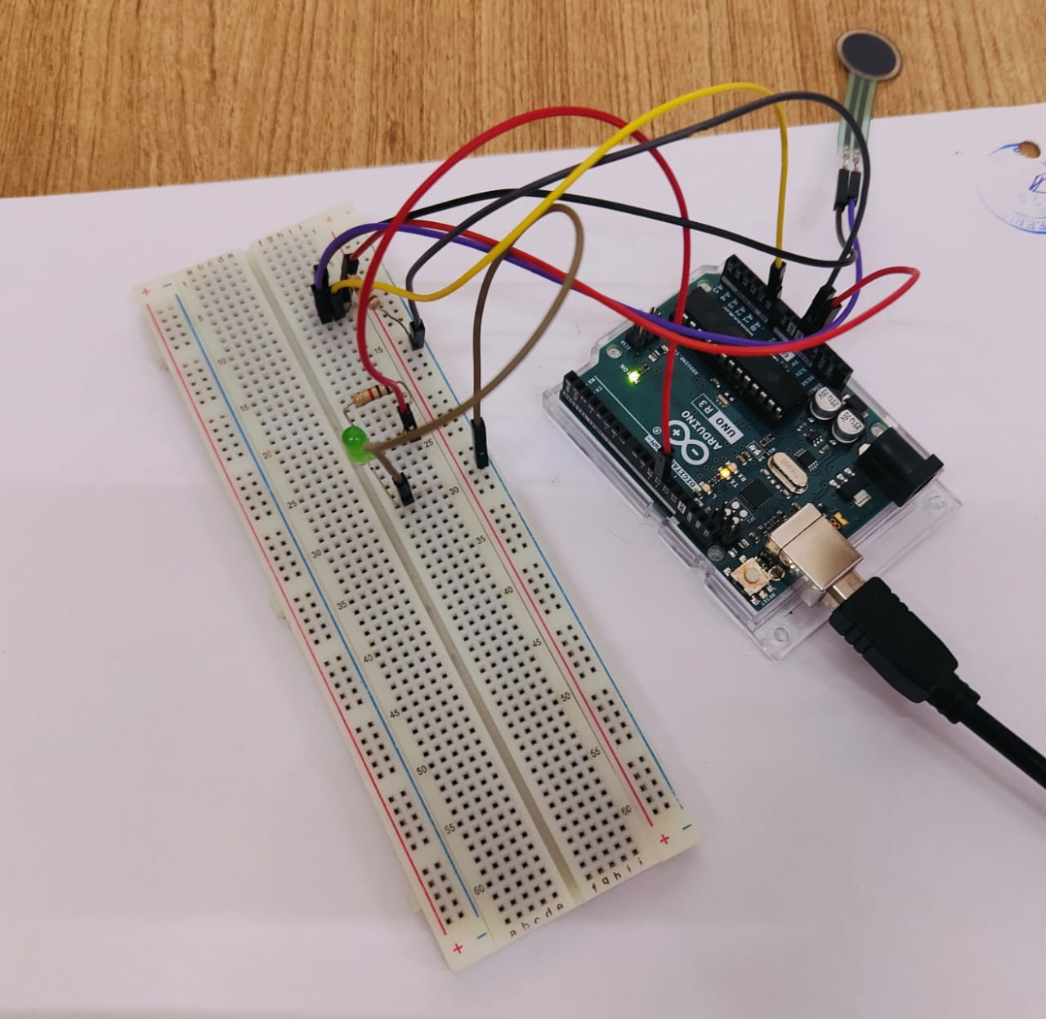

After running:

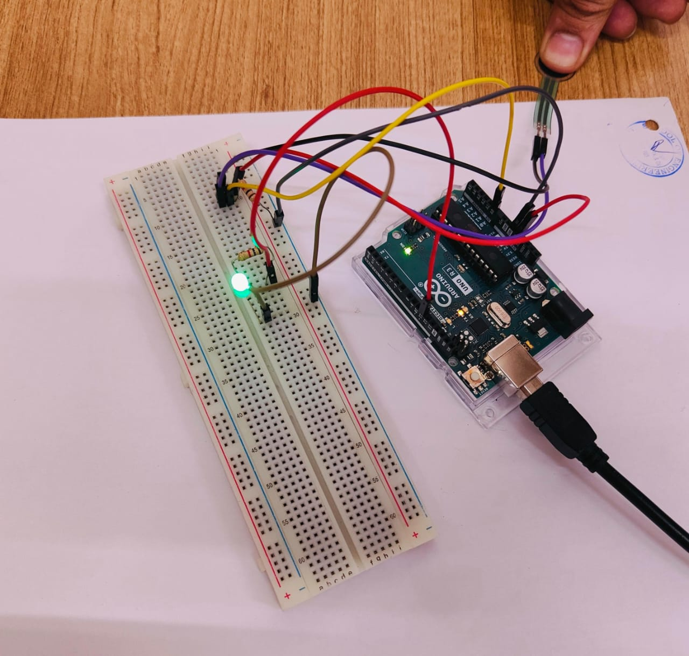

Blub is glowing

Temp Implementation:

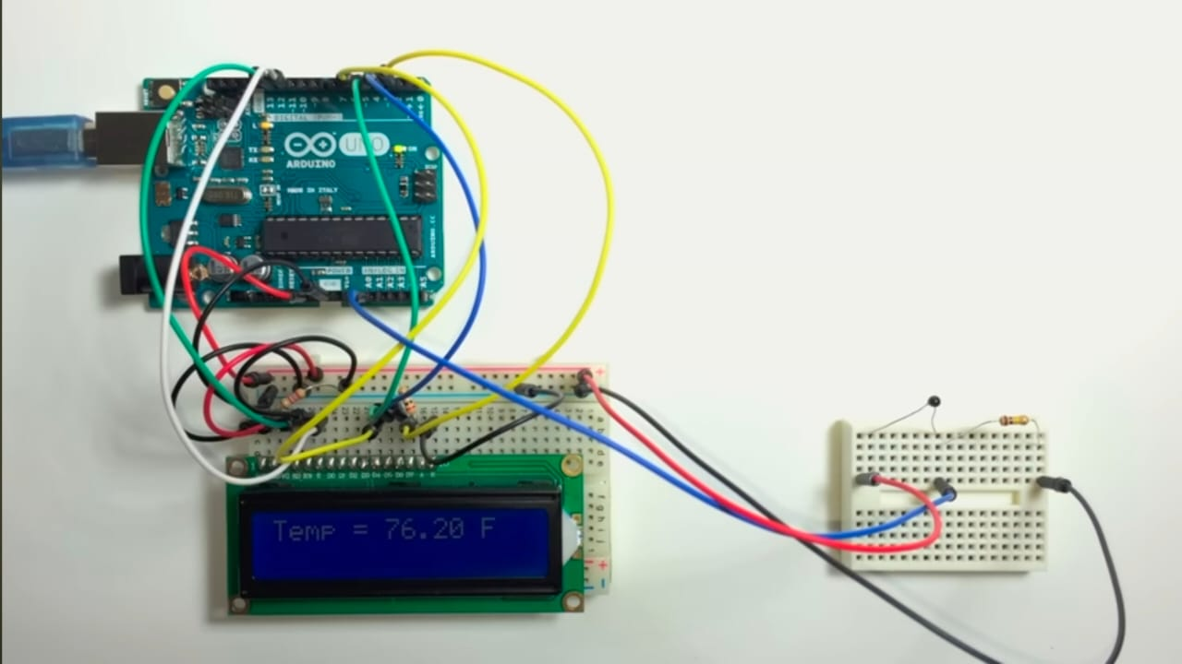

Temp is shown in the LCD

**Conclusion:**

In conclusion, the development and successful implementation of the refrigerator control system using Arduino technology mark a significant milestone in the realm of household appliances. This innovative system offers users a comprehensive solution for ensuring optimal storage conditions, enhancing convenience, and promoting energy efficiency.

Through the integration of various sensors and actuators, the system effectively monitors and regulates temperature levels, detects motion, and provides real-time feedback to users. The inclusion of features such as item quantity assessment and energy-efficient operation further enhances the system's functionality and practicality in both domestic and commercial environments.

The refrigerator control system represents a notable advancement in leveraging technology to address everyday challenges and improve quality of life. Its intuitive interface, intelligent control algorithms, and sustainability features set a new standard for modern refrigeration solutions.

Future Work:

While the current implementation of the refrigerator control system has achieved commendable results, there are several promising avenues for future exploration and enhancement:

1. IoT Integration:

Integrating Internet of Things (IoT) capabilities would enable remote monitoring and control of the refrigerator system, providing users with greater flexibility and accessibility.

2. Machine Learning Algorithms:

Incorporating machine learning algorithms could enable the system to adapt and optimize its operation based on user preferences and usage patterns, leading to even more personalized and efficient performance.

3. Energy Harvesting:

Exploring energy harvesting techniques could further improve the system's energy efficiency and sustainability, reducing reliance on traditional power sources.

4. Enhanced User Interface:

Upgrading the user interface with advanced features such as touchscreen displays or voice-activated controls would enhance user interaction and usability.

5. Advanced Sensing Technologies:

Integrating advanced sensing technologies like RFID or image recognition could enable more sophisticated inventory management and item tracking capabilities.

By pursuing these avenues of future work, the refrigerator control system can continue to evolve and innovate, meeting the evolving needs and expectations of users while contributing to a more sustainable and technologically advanced future.